National University of Computer and Emerging Sciences



**Laboratory Manual**

***(OOAD)***

|  |  |
| --- | --- |
| Semester | Fall 2018 |

Department of Computer Science

FAST-NU, Lahore

Keep the following good programming practices in mind when writing your code:

* Comment your code intelligently.
* Indent your code properly.
* Use meaningful variable names.
* Use meaningful prompt lines/labels for input/output.
* use meaningful project and JAVA file name

**Task 1 (Practice)**

Copy the contents of main given java file (OOABLAB.java) and then past in your java file and then run the code. Find out what is going on this file. (For a safe copy past, Project name should be OOAB LAB and JAVA file name should be OOABLAB)

**Task 2 (Practice)**

There are 3 folders named as Association, Aggregation and Composition. Each folder has its JAVA files.

Create a Java Project and create 3 packages named as Association, Aggregation and Composition. Then create JAVA files in each package. Code and name of JAVA files are in given folders. Your hierarchy should be like this.

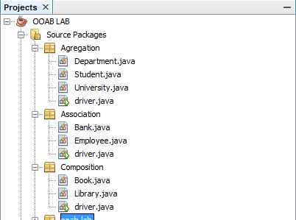

Now understand flow and Association, Aggregation and Composition.

Run each of driver program. Right click on your desired driver program and then run it.

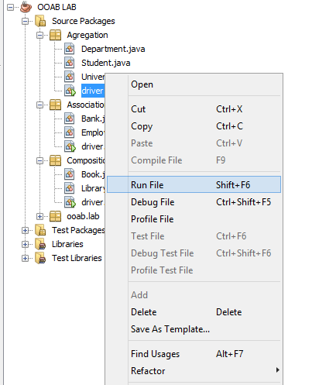

**Task 3 (Association)**

**Exercise 1:**

Make a class Student that has following data members:

name;

rollNo;

cgpa;

Student class provides a constructor, overloaded constructor and a function **Print** that prints students name and roll number on screen in following format:

StudentName (RollNo.)

For Example, Aslam Baig (12L9356)

**Exercise 2:**

Write following piece of code in your main function it should create six students with information provided.

|  |
| --- |
| Student s1 = new Student ("12L1111", "Hashim Amla", 3.99);  Student s2 = new Student ("13L1121", "Virat Kohli", 3.45);  Student s3 = new Student ("13L1126", "Quinton de Kock", 2.98);  Student s4 = new Student ("14L1361", "Joe Root", 2.99);  Student s5 = new Student ("14L1124", "Martin Guptil", 3.09);  Student s6 = new Student ("15L1314", "Rohit Sharma", 3.19); |

**Exercise 3:**

A Student Society has a president and five members from students. Make a class Society that has following private data members:

nameOfSociety;

president //is also a student;

members //are also student;

The Society class has a default constructor and an overloaded constructor that takes the name of society as parameter. what should the constructor do?

**Exercise 4:**

Write a member function of Society class **PrintInfo** that prints name of society and details of its members and president using the **Print** function of Student class. What should function do if some member does not exist?

**Exercise 5:**

Add following lines in your main function it should give following output:

|  |
| --- |
| Society sports = new Society ("Sports");  sports.PrintInfo(); |

**Output:**

|  |
| --- |
| Society Name: Sports  President: Not Available  Member 1: Not Available  Member 2: Not Available  Member 3: Not Available  Member 4: Not Available  Member 5: Not Available  Press any key to continue . . . |

Why is it displaying Not Available in members’ information? Because president and members are currently pointing to NULL. We need to point these pointers to students’ objects in order to create association between sports society and students.

**Exercise 6:**

Make a member function **AppointPresident** in Society class that takes a student object by reference and appoints it to president’s position if the position is vacant and the cgpa of student is above 3.00. Display appropriate error message otherwise. Do you need to add Getters in Students class to accomplish this task?

**Exercise 7:**

Add following lines in your main function and verify the output:

|  |
| --- |
| sports.AppointPresident(s3);  sports.AppointPresident(s1);  sports.AppointPresident(s2); |

**Output:**

|  |
| --- |
| ...  Quinton de Kock cannot be appointed as President. CGPA criteria not met.  Hashim Amla has been appointed as President.  Virat Kohli cannot be appointed as President. President position is NOT vacant.  Press any key to continue . . . |

Note: AppointPresident need to call GetName of student in order to print this message.

**Task 4 (Composition)**

You have a frame class each frame can have many objects. Each object has some properties.

You have following objects

1. Button: It has a text statement, x and y positon and size.
2. Check Box: It has a list of text statements, x and y position, count of statements and size of check box.
3. Drop Down: It has a list of text statements, x and y position and count of statements.
4. Text Box: Size of text, Text Statement and x and y position
5. Image: Size of image in KBs (not more than 25 KB), x and y position and type of image (JPFG,PNG,GIF)

Create above objects with their respective properties and create a proper menu which take user input to create a frame (no need to create an actual frame just input the information of frame). For example your start could be

|  |
| --- |
| 1. Press 1 to insert a Text Box 2. Press 2 to insert a Check Box 3. Press 3 to insert a Button 4. Press 4 to insert a Drop Down 5. Press 5 to insert a Image 6. Display Frame (Display information of frame) 7. Exit   >> 1  Insert Text size  >> 12  Enter Text  >> Name  Enter x point of text box  >> 5  Enter y point of text box  >> 5  ………………….. |